Gender Differences or Schmifferences: Testing Replication with Open-Source Data

Bradley Allen
School of Computing and Information Sciences, Willamette University
DATA 510: Data Science Capstone Project
August 14, 2026

Abstract

In 2011, a series of replication failures plunged the psychological sciences into a crisis of public trust. While methodological improvements over the last 15 years have begun to repair that trust, the emphasis on novel findings by publishers has artificially restricted replication research. Because replication research is vital to progressing psychological science, the present study replicated past findings of gender differences in personality and experiencing depression, anxiety, and stress in a large sample (N = 38,885). Responses from the Answers to the Depression Anxiety Stress Scales data set were analyzed. Results replicated past findings that significant small to moderate personality differences existed between males and females, with females scoring higher on agreeableness and lower on emotional stability compared to males (d = .19, d = -.35, respectively). Multiple regression revealed emotional stability was the strongest predictor of negative mental health, while personality was generally a better predictor of depression, anxiety, and stress for males (R² = .34, .27, .43, respectively) compared to females (R² = .31, .24, .40, respectively). Independent samples t-tests revealed females scored significantly higher on anxiety (d = .31) and stress (d = .34) compared to males. Multi-group confirmatory factor analysis was conducted on the Depression Anxiety Stress Scales, which demonstrated full invariance across groups, thereby validating group mean comparisons. This research highlights the importance of open-source software and open-source data in service of replication and further contributes to the repair of public trust in psychological science.

Introduction
Insanity is doing the same thing over and over again, but expecting different results.
– Rita Mae Brown (1983, p. 86)
To borrow from Rita Mae Brown, sanity is undercut when attempted replication yields different results over and over again. Indeed, failure to replicate psychological studies has led to a crisis of public trust in psychological science (Anvari & Lakens, 2018; Patil et al., 2016; Shrout & Rodgers, 2018).
Some researchers have cited unpublished papers and publication bias as main contributors to the crisis, while others have cited poor experimental design, breadth of psychological subfields with varying research standards, and outsized media attention to replication failure (Bogdan, 2025; Johnson et al., 2016; Ke et al., 2017; Youyou et al., 2023).
In recent years, methodological improvements have begun to repair the damage, yielding what has been deemed a “credibility revolution” (Korbmacher et al., 2023, p. 1). Despite the credibility revolution, there remains a strong need for replication targets (Pittelkow et al., 2023).
Taken together, declaring a significant finding, then failing to replicate it reduces the credibility of scientific findings, and diminishes public trust, necessitating more studies of replication not only to repair the damage, but also to act as a sort of sanity check.
Replication
Nosek and Errington (2022) suggested that researchers are remiss to replicate because it is seen as “a boring, uncreative, housekeeping activity” despite replication being a “vital contributor to research progress” (p. 1). They argued this mindset stemmed from the strict definition of replication as algorithmically following the steps of another researcher. Such a definition may be impossible to satisfy because observational research, for example, cannot be replicated exactly (e.g., an earthquake or election that has occurred implies the novelty of the experience for those who observed it is impossible to replicate).
Rather than restricting researchers to an exact step-by-step model, Nosek and Errington offered a new definition of replication: “[A] study for which any outcome would be considered diagnostic evidence about a claim from prior researchers” (p. 2). They concluded that this definition reduced emphasis on study characteristics and increased emphasis on interpreting outcomes. Critically, this would grant researchers the methodological breathing room to meaningfully engage in replication without reducing the act to a boring housekeeping activity.
Researchers have further called for methodological change when conducting novel research. Shrout and Rodgers (2018) recommended following open science conventions such as pre-registration to prevent post-hoc revisions to research questions or p-hacking. They further recommended improvements to power analyses, deeper consideration of effect sizes (e.g., heterogeneity of results due to different sample sizes in the replication study), and increased disclosure of nonsignificant findings. Koole and Lakens (2012) suggested that publications link replication studies to the original papers, effectively creating co-citations as incentives.
Broad consensus among research psychologists is that replication is necessary to validate existing findings, legitimize the field of study, and bolster public trust (Shrout & Rodgers, 2018; Youyou et al., 2023). Given the stakes, as Amir and Sharon (1990) put it, replication research is a must. One way to broaden engagement with replication research is to open the field to researchers by offering access to open-source data.
Open-Source Data
The Open-Source Psychometrics Project (2019) makes available large, open-source data sets, often personality-centric, for use in publications. The present study analyzed the Answers to the Depression Anxiety Stress Scales data set available from the Open Psychometrics (2019) webpage. This data set contained more than 39 thousand responses to the Depression Anxiety Stress Scales (DASS) 42-item measure (P. F. Lovibond & Lovibond, 1995), Ten Item Personality Inventory (TIPI; Gosling et al., 2003), and multiple demographic variables, such as race, gender, and orientation.
Given the breadth of available variables (172 in total), the use of validated psychological scales, the large sample size, and the duration of data collection (i.e., 3 years from 2017 to 2019), this data set was ideal for exploring the relationship between personality, depression, anxiety, stress, and demographic variables (e.g., gender).
Gender Differences
When it comes to personality, depression, anxiety, and stress, there are small to moderate differences between males and females. For example, females tend to report higher scores on personality traits agreeableness and lower scores in trait emotional stability compared to males (Lippa, 2010; Weisberg et al., 2011). Agreeableness is defined as a person’s tendency to seek social harmony and cooperation over competition or self-interest, while emotional stability is characterized by the ability to remain calm and resilient under pressure (Goldberg, 1990; McCrae & John, 1992).
Emotional stability is often considered the strongest predictor of mental health indicators such as stress and anxiety for both males and females, though personality tends to better predict mental health indicators for males compared to females (Alizadeh et al., 2018; Uliaszek et al., 2010).
Given these differences, the inclusion of DASS-42, TIPI, and demographics variables like gender in the Answers to the Depression Anxiety Stress Scales data set made it ideal for exploring gender differences in personality and mental health indicators (e.g., depression, anxiety, stress).
Present Study
The goal of this project is to replicate findings of gender differences in personality, depression, anxiety, and stress. With respect to depression, anxiety, and stress, this study will include multi-group confirmatory factor analysis (CFA) of the DASS 42- and 21-item scales to replicate findings of measurement invariance across gender.
Target CFA studies include Gomez et al. (2014) and Lu et al. (2018), both of which found the DASS 42- and 21-item measures performed equally for males and females. Target personality studies include Lippa (2010) and Weisberg et al. (2011). Target studies on gender differences in the relationship between personality and mental health include Alizadeh et al. (2018) and Uliaszek et al. (2010). To provide adequate coverage of personality as a predictor of mental health, standardized regression coefficients from studies by Sambol et al. (2022) and Vujicic and Randjelovic (2017) will serve as contrasts for findings in this study.
With methodological changes such as using open-source software to analyze data collected from a large, multinational sample, this project aims to answer how well open-source data replicates findings of gender differences in personality and experiencing depression, anxiety, and stress.
Method
Participants
The raw data contained 39,775 observations. Participants were required to pass an attention check to be included in the study. The attention check consisted of a 16-word list (e.g., boat, paucity, lucid), 3 of which were fake (e.g., cuivocal, florted, verdid). Participants were instructed to check a box next to words whose definitions they knew for certain. Those who checked boxes for all 3 words were excluded from analysis, resulting in a reduction of 326 participants.
Additionally, the study required that participants identified as male or female. As a result, 540 participants who selected “other” and 67 participants who did not provide a response were excluded.
Finally, a total of 7 participants who listed their age as greater than 100 were removed. The remaining sample size was 38,835. Demographic results are reported in Table 1. Additional demographic analyses can be found in the Exploratory Data Analysis section.
Procedure
Adjustments were made to the DASS-42 and TIPI scores. The DASS-42 responses were recorded on a scale from 1-4 but should have been 0-3. This was corrected by subtracting 1 from each participant’s response. The scores were then summed and stored as depression, anxiety, and stress scores, respectively (P. F. Lovibond & Lovibond, 1995). Scores for DASS-21 were extracted from the 42-item measure, then doubled (S. H. Lovibond & Lovibond, 1995).
Responses to TIPI questions 2, 4, 6, 8, and 10 were reverse scored by subtracting each response from 8 (e.g., 8 - 1, 8 - 2, etc.) before taking the mean of each set and assigning them to their respective trait (Gosling et al., 2003).
User input of college majors was cleaned using the stringdist package (Loo, 2014), with the Jaro-Winkler algorithm enabled (Jaro, 1989; Winkler, 1990). This method finds the closest approximation of a specified major (e.g., user input of social psychology becomes psychology). The resulting standardized majors were grouped into 10 common categories (e.g., STEM and Natural Sciences, Health & Medicine). Given the potential for misclassification, the results were used for exploratory analysis only.
Measures
Depression, Anxiety, and Stress
Depression, anxiety, and stress scores were calculated using the 42-item Depression Anxiety Stress Scale (DASS-21; S. H. Lovibond & Lovibond, 1995). Depression was assessed using a 14-item scale that included items such as “I felt sad and depressed” and “I just couldn’t seem to get going.” Anxiety was assessed using a 14-item scale that included items such as “I had difficulty swallowing” and “I felt terrified.” Stress was assessed using a 14-item scale that included items such as “I found it hard to wind down” and “I tended to over-react to situations.”
Items for all three scales were measured using a 4-point Likert scale (0 = Did not apply to me at all, 3 = Applied to me very much, or most of the time). Descriptive statistics are given in Table 2.
Personality
Personality scores were calculated using the Ten Item Personality Inventory (Gosling et al., 2003). Participants responded to the prompt “I see myself as” and rated items such as “Extraverted, enthusiastic” and “Calm, emotionally stable.” Extraversion, agreeableness, conscientiousness, emotional stability, and openness to experience were all assessed using a 2-item scale, on a 7-point Likert scale (1 = Disagree strongly, 7 = Agree strongly). Descriptive statistics are given in Table 4.
Data Analysis
Software Packages
This project was coded in R (R Core Team, 2026) using R Studio (Posit Team, 2026) with the following packages: broom (Robinson et al., 2026), effectsize (Ben-Shachar et al., 2020), kableExtra (Zhu et al., 2024), knitr (Xie, 2025), lavaan (Rosseel, 2012), lm.beta (Behrendt, 2025), naniar (Tierney & Cook, 2023), patchwork (Pedersen, 2025), purrr (Wickham et al., 2026), scales (Wickham et al., 2025), semTools (Jorgensen et al., 2026), tibble (Müller et al., 2026), and tidyverse (Wickham et al., 2019).
Missing Data
No patterns of missing data were found for mental health indicators (i.e., DASS), personality, or gender. The college major column contained the highest percentage of missing data at about 35%, likely due to individuals who reported educational attainment not exceeding the high school level. The next highest percentage of missing data was in sexual orientation at 8%. There was less than 1.5% missing data in all other categories (Fig. 1).
Methodological Variations
There are several methodological variations between the present study and the target studies. The primary difference is in the analytic tools. Researchers in the target studies used software such SPSS and Mplus to perform statistical analysis, while this study used R Studio and various software packages (e.g., lavaan).
Secondly, given the breadth of this project, some analyses were partially replicated. For example, Weisberg et al. (2011) conducted independent samples t-tests on an expanded set of Big Five domains (e.g., enthusiasm, politeness), while this study only explored the core traits (i.e., openness, conscientiousness, extraversion, agreeableness, and neuroticism or emotional stability).
Finally, this study employed multiple regression to explore the relationship between personality as a predictor of mental health indicators while Alizadeh et al. (2018) conducted Chi-square and multivariate analysis of variance to compare groups based on clinical cut-off scores. These studies serve as a general target to show that neuroticism the best predictor for depression, anxiety, and stress, while personality tends to be a better predictor for males than females. Multiple regression results (Sambol et al., 2022; Vujicic & Randjelovic, 2017) from gender-combined studies will serve as a baseline comparison for multiple regression results by gender from this study. The goal is to replicate the trends.
Results
Confirmatory Factor Analysis (CFA)
Multi-group CFA was conducted on the 42- and 21-item DASS following Brown’s (2015) framework up to equal indicator error variances (i.e., strict measurement invariance) to ensure comparisons of group means were appropriate (Furr, 2018; Liu et al., 2017; Wu & Estabrook, 2016). CFA analyses were conducted in R Studio using the lavaan package (Rosseel, 2012), in accordance with syntax described by Hirschfeld and Brachel (2014) and Svetina et al. (2020).
Six models were created: One model each for males and females, an equal form (configural) model (group = gender), an equal factor loadings (weak) model (group.equal = loadings), an equal intercepts (strong) model (group.equal = loadings, thresholds), and an equal indicator error variances (strict) model (group.equal = loadings, thresholds, residuals). Because the items utilize a 4-point Likert response scale, the data were treated as ordinal categories.
CFA Models for DASS-42 and DASS-21 Item Scales
Models were estimated using the Weighted Least Squares Mean and Variance (WLSMV) adjusted estimator which provides robust standard errors and fit indices suited for non-continuous, non-normal data (Finney & DiStefano, 2006; Hirschfeld & Brachel, 2014; Rosseel, 2012).
Model fit was evaluated using standard psychometric cutoffs: a Comparative Fit Index (CFI) and Tucker-Lewis Index (TLI) of $≥.90$ for acceptable fit and $≥.95$ for good fit, a Standardized Root Mean Square Residual (SRMR) $≤.08$, and a Root Mean Square Error of Approximation (RMSEA) of $≤.06$ for good fit and $≤.08$ for acceptable fit (Bentler & Bonett, 1980; Hu & Bentler, 1999; MacCallum et al., 1996; Marsh et al., 2004). Full model results are reported in Table 3.
The initial baseline CFA for the DASS-42 revealed structural strain $({\text{CFI}}_{\text{robust}}=.881,{\text{TLI}}_{\text{robust}}=.875)$. Examination of the modification indices indicated substantial unmodeled residual covariance between similar items within the same subscales (e.g., trembling items Q7A and Q41A; meaningless/empty life items Q21A and Q38A). After specifying five local residual error covariances to absorb this method effects variance, the adjusted DASS-42 model achieved acceptable fit $({\text{CFI}}_{\text{robust}}=.910,{\text{TLI}}_{\text{robust}}=.905,{\text{RMSEA}}_{\text{robust}}=.063,\text{SRMR}=.039)$.
Conversely, the DASS-21 baseline model achieved similar results without any post-hoc modifications $({\text{CFI}}_{\text{robust}}=.932,{\text{TLI}}_{\text{robust}}=.923,{\text{RMSEA}}_{\text{robust}}=.073,\text{SRMR}=.038)$. Furthermore, based on cut-off scores established by Nunnally (1994), the subscales demonstrated good $(α≥.80)$ model-based internal consistency using McDonald’s omega (McDonald, 1999), yielding coefficients of $ω=.92$ for depression, $ω=.84$ for anxiety, and $ω=.87$ for stress. This approach was preferred over Cronbach’s alpha because coefficient omega provides a more accurate estimate of internal consistency when handling categorical data and when the assumption of tau-equivalence is violated (Hayes & Coutts, 2020; McNeish, 2018).
Due to the large sample size ($N=38,835$), the Satorra-Bentler scaled chi-square difference test ($Δχ^{2}$) is highly oversensitive to trivial group variations and expectedly yielded statistically significant results. Therefore, invariance was determined by tracking changes in the comparative fit index ($Δ\text{CFI}$), where a value $≤.010$ indicates that invariance holds (Chen, 2007; Cheung & Rensvold, 2002). For the DASS-21, configural invariance was established (${\text{CFI}}_{\text{robust}}=.932$, ${\text{RMSEA}}_{\text{robust}}=.073$).
The highly constrained equal indicator error variances (strict) model fit the data equally well (${\text{CFI}}_{\text{robust}}=.932$, ${\text{RMSEA}}_{\text{robust}}=.071$). The resulting change in fit was negligible ($Δ\text{CFI}=0$, $Δ\text{RMSEA}=-.002$), confirming full scalar invariance across genders. For the adjusted DASS-42, the equal form (configural) model (${\text{CFI}}_{\text{robust}}=.910$, ${\text{RMSEA}}_{\text{robust}}=.063$) was statistically compared against the constrained equal indicator error variances (strict) model (${\text{CFI}}_{\text{robust}}=.910$, ${\text{RMSEA}}_{\text{robust}}=.062$). Mirroring the short-form findings, the fit shift was effectively zero ($Δ\text{CFI}=0$, $Δ\text{RMSEA}=-.001$), establishing full scalar invariance for the 42-item scale.
Collectively, these invariance findings verify that item mechanics, factor structures, and category thresholds mean the same thing to both men and women, validating subsequent comparisons of latent factor means or observed manifest sum scores. Because DASS-21 performed equally to DASS-42, subsequent analyses will be conducted using the shorter DASS-21 scale to compare observed means on depression, anxiety, and stress.
Tests for Independence
Independent samples t-tests were calculated in R using the built-in t.test() function. To estimate statistical significance without assuming equal variance, the Welch-Satterthwaite equation was used to calculate degrees of freedom (Satterthwaite, 1946; Welch, 1947). Cohen’s $d$ was calculated using the effectsize package (Ben-Shachar et al., 2020). Formulas for both functions included the arguments score ~ gender.
Personality Differences
An independent-sample t-test showed small to moderate differences in personality. On average, females reported higher scores compared to males on trait agreeableness $(M=4.60,SD=1.20 vs. M=4.37,SD=1.28; d=.19)$. Conversely, females reported lower scores compared to males on trait emotional stability $(M=3.13,SD=1.47 vs. M=3.66,SD=1.65; d=-.35)$. A full comparison across each trait can be found in Table 4. These differences are visualized in Fig. 2, which includes trait distributions, average trait differences, and QQ plots separated by gender.
Depression, Anxiety, and Stress Differences
An independent-sample t-test showed small to moderate differences in stress, depression, and anxiety. On average, females reported higher scores compared to males on DASS-21 stress $(M=22.61,SD=10.70 vs. M=18.92,SD=10.94; d=.34)$. Similarly, females reported higher anxiety scores compared to males $(M=3.13,SD=1.47 vs. M=3.66,SD=1.65; d=.31)$. The smallest difference reported was on DASS-21 depression where, on average, females reported higher scores compared to males $(M=21.17,SD=12.68 vs. M=19.95,SD=12.96; d=.10)$. A full comparison across each trait can be found in Table 5. These differences are visualized in Fig. 3, which includes DASS-21 scale distributions, average scale differences, and QQ plots separated by gender.

Regression
Personality Traits as Predictors of Stress, Depression, and Anxiety
Multiple regression analyses were conducted to examine how personality traits predict stress, depression, and anxiety by gender. Models were created using the built-in lm function in R, where personality traits were predictors of stress, depression and anxiety for females and males, respectively (e.g., stress ~ extraversion + ... + openness). Standardized regression coefficients were calculated using lm.beta (Behrendt, 2025). Full results are reported in Table 6, with standardized regression coefficients visualized by gender in Fig. 4.
Stress
The regression models explained a substantial amount of variance in stress for both females $(R^{2}=.40)$ and males $(R^{2}=.43)$. Emotional stability was the strongest predictor of lower stress levels for both females $(B=-4.25,t=-120.64,p<.001)$ and males $(B=-4.17,t=-71.07,p<.001)$. All other personality traits significantly predicted lower stress in females $(p<.001)$. For males, however, openness $(B=-0.22,t=-2.74,p=.006)$ and agreeableness $(B=-0.32,t=-4.46,p<.001)$ were significant predictors, while conscientiousness $(p=.077)$ and extraversion $(p=.074)$ did not reach statistical significance (Table 6).
Depression
The overall variance explained in depression was similar between the groups, accounting for 31% in females and 34% in males (Table 6). Emotional stability was again the strongest predictor of lower depression for both females $(B=-3.78,t=-84.65,p<.001)$ and males $(B=-3.37,t=-45.07,p<.001)$. Agreeableness, conscientiousness, and extraversion were highly significant predictors of lower depression across both genders $(p<.001)$. Openness did not significantly predict depression for either females $(B=0.08,t=1.44,p=.149)$ or males $(B=0.04,t=0.40,p=.688)$.
Anxiety
Personality traits predicted 24% of the variance in anxiety for females and 27% for males (Table 6). Emotional stability consistently served as the strongest predictor of lower anxiety for females $(B=-3.06,t=-79.08,p<.001)$ and males $(B=-2.88,t=-47.54,p<.001)$. While openness, conscientiousness, and extraversion predicted lower anxiety levels across both groups $(p≤.005)$, agreeableness showed a diverging pattern: it predicted significantly lower anxiety in females $(B=-0.18,t=-3.87,p<.001)$ but significantly higher anxiety in males $(B=0.29,t=4.00,p<.001)$.

Discussion
The findings in this study largely replicated previous findings. Multi-group CFA analyses revealed the 42-item DASS scale did not achieve good fit. However, after accounting for highly correlated subscales, the adjusted 42-item scale achieved good fit and demonstrated full invariance across each model (i.e., weak, strong, strict), while the 21-item scale achieved good fit without adjustment, thereby replicating research by Gomez et al. (2014) and Lu et al. (2018).
This study further replicated findings by Lippa (2010) and Weisberg et al. (2011) who found small to moderate differences in personality where females, compared to males, reported higher average scores on trait agreeableness and lower average scores on trait emotional stability (Table 7).
Additionally, this study replicated research by Alizadeh et al. (2018) and Uliaszek et al. (2010) who found emotional stability was the best predictor of mental health indicators for males and females. Similarly, although females reported higher scores across each indicator compared to males, these differences tended to be small to moderate, and personality was a better predictor of stress, anxiety, and depression for males compared to females.
Regression coefficients for females and males demonstrated similar patterns to research by Sambol et al. (2022), and Vujicic and Rendjelovic (2017), who found that compared to other personality traits, emotional stability exerted the most influence over depression, anxiety, and stress, with similar r-squared values from the target populations compared to females and males separately from this study (Table 8).
With respect to the replication crisis, the objective of this study was to add to the credibility revolution in psychological science as described by Korbmacher et al. (2023). Given the large sample size (e.g., 38,885), and different methodology (e.g., most target studies used SPSS for analyses, where this project used R Studio), this report does not claim to offer definitive evidence on the subject; rather, it offers supporting evidence with small methodological differences toward the same conclusions as past studies.
Nosek and Errington (2020) argued that replication with a moderately revised methodological treatment was vital to progressing research. This project accomplished that by analyzing open-source data with open-source software using robust methodology and replicating significant findings from past research.
As a result, more evidence has been added to gender differences in personality and experiencing depression, anxiety, and stress simultaneously providing a boost to sanity and addressing the question of schmreduplication (Nevins & Vaux, 2003): Where gender is concerned, there are differences, not schmifferences.

Limitations
The foremost limitation is that of the survey design. Participants were selected via convenience sampling (e.g., may have sought out the survey or happened on it by accident). Further, anonymous survey completion means that the same person could have completed the survey multiple times.
A second limitation is that of project constraints. This project required a large data set, which meant that reducing the sample size by filtering for unique locations and dropping outlier completion times, then conducting random sampling would have been too restrictive. To maintain parity across projects (e.g., the machine learning component, sample parity was required), such methodological improvements were not possible.
Finally, researcher domain knowledge was extensively tested, often encountering vast limitations which were addressed by engaging relevant literature. Candidly, this was an ambitious project for one person to complete. Although it was completed with the utmost care, and with an eye toward accuracy, either a lack of domain knowledge or human error may have introduced errors in the analyses.
Future Directions
With corrections to sampling and a narrower scope, this data set offers a tremendous avenue of research. For example, the relationship between DASS-21 indicators of mental health and education level could be explored. Alternatively, contrasts between majors could be made (e.g., do college graduates with humanities majors experience different levels of stress compared to STEM majors?). Personality differences between males and females and college majors could even be explored. Given the rich selection of variables, researchers may find more studies to replicate on differences between religious and irreligious populations.

Table 1
Demographic Characteristics by Gender
 |  | Female (n = 30156) |  |  | Male (n = 8679)
Variable and Group |  | $$n$$ | % |  | $$n$$ | %
Country
United States |  | 5375 | 17.82 |  | 2340 | 26.96
Australia |  | 404 | 1.34 |  | 178 | 2.05
Canada |  | 625 | 2.07 |  | 305 | 3.51
Great Britain |  | 749 | 2.48 |  | 378 | 4.36
Indonesia |  | 745 | 2.47 |  | 132 | 1.52
Malaysia |  | 18085 | 59.97 |  | 3401 | 39.19
Philippines |  | 590 | 1.96 |  | 142 | 1.64
Other |  | 3582 | 11.88 |  | 1802 | 20.77
Education
Less than high school |  | 2876 | 9.66 |  | 915 | 10.68
High school |  | 11111 | 37.33 |  | 3576 | 41.72
Undergraduate degree |  | 11942 | 40.12 |  | 2981 | 34.78
Graduate degree |  | 3835 | 12.88 |  | 1099 | 12.82
Race
Arab |  | 235 | .78 |  | 85 | .98
Asian |  | 19032 | 63.11 |  | 3898 | 44.91
Black |  | 406 | 1.35 |  | 168 | 1.94
Indigenous Australian |  | 13 | .04 |  | 6 | .07
Native American |  | 143 | .47 |  | 58 | .67
White |  | 6688 | 22.18 |  | 3409 | 39.28
Other |  | 3639 | 12.07 |  | 1055 | 12.16
Age (years)
Min |  | 13 |  |  | 13
Max |  | 85 |  |  | 89
$$M$$ |  | 22.99 |  |  | 25.05
$$SD$$ |  | 7.89 |  |  | 10.37
Note. M = Mean; SD = Standard Deviation.

Table 2
DASS-21 Descriptive Statistics by Gender
Scale |  | Female (n = 30156) |  |  | Male (n = 8679)
Subscale |  | $$M$$ | $$SD$$ |  | $$M$$ | $$SD$$
Depression |  | 21.17 | 12.68 |  | 19.95 | 12.96
Dysphoria |  | 3.63 | 2.13 |  | 3.28 | 2.19
Hopelessness |  | 2.90 | 2.27 |  | 2.80 | 2.3
Devaluation of Life |  | 2.70 | 2.33 |  | 2.60 | 2.34
Self-Deprecation |  | 3.37 | 2.3 |  | 3.06 | 2.34
Lack of Interest |  | 3.06 | 2.21 |  | 2.91 | 2.24
Anhedonia |  | 2.46 | 2.07 |  | 2.36 | 2.08
Inertia |  | 3.05 | 2.13 |  | 2.93 | 2.15
Anxiety |  | 16.26 | 10.47 |  | 13.04 | 9.99
Autonomic Arousal |  | 6.34 | 4.93 |  | 5.30 | 4.73
Skeletal Musculature Effects |  | 1.93 | 2.08 |  | 1.47 | 1.94
Situational Anxiety |  | 3.46 | 2.11 |  | 2.88 | 2.16
Anxious Affect |  | 4.53 | 3.55 |  | 3.38 | 3.36
Stress |  | 22.61 | 10.7 |  | 18.92 | 10.94
Difficulty Relaxing |  | 2.99 | 2.09 |  | 2.80 | 2.14
Nervous Arousal |  | 2.93 | 2.12 |  | 2.52 | 2.13
Easily Upset |  | 7.18 | 3.73 |  | 5.61 | 3.83
Irritable |  | 6.29 | 3.55 |  | 5.08 | 3.60
Impatient |  | 3.23 | 2.15 |  | 2.91 | 2.17
Note. M = Mean; SD = Standard Deviation.

Table 3
Comparison of Model Fit Indices for DASS-42 Adjusted and DASS-21 Models
Model | Chi-Sq (Scaled) | $df$ (Scaled) | RMSEA (Robust) | RMSEA CI LL | RMSEA CI UL | SRMR | CFI (Robust) | TLI (Robust)
DASS-42 Adjusted Models
M1: Single-group (Males) | 23427.9 | 811 | .064 | .063 | .065 | .039 | .908 | .903
M2: Single-group (Females) | 90173.9 | 811 | .062 | .062 | .063 | .039 | .911 | .905
M3: Equal form | 110540.0 | 1622 | .063 | .062 | .063 | .039 | .910 | .905
M4: Equal factor loadings | 67809.4 | 1661 | .062 | .062 | .062 | .040 | .910 | .907
M5: Equal Intercepts | 110147.4 | 1703 | .063 | .062 | .063 | .039 | .910 | .909
M6: Equal indicator error variances | 69002.8 | 1745 | .062 | .062 | .062 | .040 | .910 | .911
DASS-21 Models
M1: Single group (Males) | 6718.2 | 186 | .072 | .070 | .073 | .039 | .935 | .926
M2: Single group (Females) | 24891.1 | 186 | .073 | .072 | .074 | .038 | .931 | .922
M3: Equal form | 31119.7 | 372 | .073 | .072 | .073 | .038 | .932 | .923
M4: Equal factor loadings | 20987.1 | 390 | .071 | .070 | .072 | .039 | .932 | .926
M5: Equal Intercepts | 30530.7 | 411 | .073 | .072 | .074 | .038 | .932 | .931
M6: Equal indicator error variances | 21664.8 | 432 | .071 | .070 | .072 | .039 | .932 | .934

Table 4
Difference in Average Ten-item Personality Inventory Scores by Gender
Scale  Gender | $$n$$ | $$M$$ | $$SD$$ | $$t$$ | $$df$$ | $$p$$ | Cohen’s d
Openness to Experience |  |  |  | -12.76 | 13531.8 | < .001 | -.16
Female | 30156 | 4.55 | 1.32
Male | 8679 | 4.76 | 1.38
Conscientiousness |  |  |  | 6.84 | 13523.6 | < .001 | .09
Female | 30156 | 4.26 | 1.47
Male | 8679 | 4.14 | 1.55
Extraversion |  |  |  | 5.95 | 13516.0 | < .001 | .07
Female | 30156 | 3.76 | 1.25
Male | 8679 | 3.66 | 1.31
Agreeableness |  |  |  | 14.84 | 13371.8 | < .001 | .19
Female | 30156 | 4.60 | 1.20
Male | 8679 | 4.37 | 1.28
Emotional Stability |  |  |  | -27.07 | 12861.0 | < .001 | -.35
Female | 30156 | 3.13 | 1.47
Male | 8679 | 3.66 | 1.65
Note. M = Mean; SD = Standard Deviation.

Table 5
Difference in Total DASS-21 Scores by Gender
Scale  Gender | $$n$$ | $$M$$ | $$SD$$ | $$t$$ | $$df$$ | $$p$$ | Cohen’s d
Depression |  |  |  | 7.78 | 13810.2 | < .001 | .10
Female | 30156 | 21.17 | 12.68
Male | 8679 | 19.95 | 12.96
Anxiety |  |  |  | 26.17 | 14612.5 | < .001 | .31
Female | 30156 | 16.26 | 10.47
Male | 8679 | 13.04 | 9.99
Stress |  |  |  | 27.78 | 13806.2 | < .001 | .34
Female | 30156 | 22.61 | 10.70
Male | 8679 | 18.92 | 10.94
Note. M = Mean; SD = Standard Deviation.

Table 6
Multiple Regression Results for Personality Traits Predicting Depression, Anxiety, and Stress
 | Female |  |  |  |  | Male
Predictor Variable | $$B$$ | β | $$t$$ | $$p$$ |  | $$B$$ | β | $$t$$ | $$p$$
Depression | $$R^{2}=.31$$ |  |  |  |  | $$R^{2}=.34$$
Intercept | 45.92 |  | 138.81 | < .001 |  | 45.92 |  | 79.62 | < .001
Openness | 0.08 | .01 | 1.44 | .149 |  | .04 | 0 | 0.40 | 0.688
Conscientiousness | -1.06 | -.12 | -24.26 | < .001 |  | -1.05 | -.13 | -13.43 | < .001
Extraversion | -1.74 | -.17 | -28.95 | < .001 |  | -2.11 | -.21 | -19.38 | < .001
Agreeableness | -0.49 | -.05 | -9.38 | < .001 |  | -0.40 | -.04 | -4.42 | < .001
Emotional Stability | -3.78 | -.44 | -84.65 | < .001 |  | -3.37 | -.43 | -45.07 | < .001
Anxiety | $$R^{2}=.24$$ |  |  |  |  | $$R^{2}=.27$$
Intercept | 32.17 |  | 112.19 | < .001 |  | 26.85 |  | 57.59 | < .001
Openness | -0.14 | -.02 | -2.79 | .005 |  | -0.41 | -.06 | -4.82 | < .001
Conscientiousness | -0.57 | -.08 | -15.12 | < .001 |  | -0.35 | -.05 | -5.60 | < .001
Extraversion | -0.65 | -.08 | -12.56 | < .001 |  | -0.31 | -.04 | -3.58 | < .001
Agreeableness | -0.18 | -.02 | -3.87 | < .001 |  | 0.29 | .04 | 4.00 | < .001
Emotional Stability | -3.06 | -.43 | -79.08 | < .001 |  | -2.88 | -.48 | -47.54 | < .001
Stress | $$R^{2}=.40$$ |  |  |  |  | $$R^{2}=.43$$
Intercept | 41.92 |  | 160.51 | < .001 |  | 37.65 |  | 83.33 | < .001
Openness | -0.16 | -.02 | -3.56 | < .001 |  | -0.22 | -.03 | -2.74 | .006
Conscientiousness | -0.37 | -.05 | -10.59 | < .001 |  | -0.11 | -.02 | -1.77 | .077
Extraversion | -0.37 | -.04 | -7.76 | < .001 |  | -0.15 | -.02 | -1.79 | .074
Agreeableness | -0.51 | -.06 | -12.25 | < .001 |  | -0.32 | -.04 | -4.46 | < .001
Emotional Stability | -4.25 | -.58 | -120.64 | < .001 |  | -4.17 | -.63 | -71.07 | < .001
Note: B = non-standard regression coefficient, β = standardized regression coefficient

Table 7
Gender Differences (Cohen’s d) in Big Five Personality Traits Study Comparisons
 | Studies
Personality Dimension | Lippa et al. (2010) | Weisberg et al. (2011) | Present Study
Openness to Experience | .01 | .27 | -.16
Conscientiousness | .09 | .06 | .09
Extraversion | .11 | .08 | .07
Agreeableness | .40 | .48 | .19
Emotional Stability | -.34 | -.39 | -.35
Note: Positive effect sizes occur when women score higher than men. Negative effect sizes occur when men score higher than women. Bolded d values indicate statistically significant effect sizes. Where emotional stability was reported as neuroticism, Cohen’s d values have been sign changed.

Table 8
Gender Differences (d) in Big Five Personality Traits Study Comparisons
 | Studies
Mental Health Indicator  Personality Dimension | Sambol et al. (2022) |  | Vujicic and Randjelovic (2017) |  | Present Study
 |  |  |  |  | Female |  | Male
 | $$R^{2}$$ | β | $$R^{2}$$ | β | $$R^{2}$$ | β | 𝑅2 | β
Depression | .36 |  | .26 |  | .31 |  | .34
Openness to Experience |  | .08 |  | 0 |  | .01 |  | 0
Conscientiousness |  | -.18 |  | -.17 |  | -.12 |  | -.13
Extraversion |  | -.09 |  | -.17 |  | -.17 |  | -.21
Agreeableness |  | -.10 |  | -.14 |  | -.05 |  | -.04
Emotional Stability |  | -.49 |  | -.34 |  | -.44 |  | -.43
Anxiety | .28 |  | .27 |  | .24 |  | .27
Openness to Experience |  | -.01 |  | 0 |  | -.02 |  | -.06
Conscientiousness |  | -.11 |  | -.12 |  | -.08 |  | -.05
Extraversion |  | .04 |  | -.07 |  | -.08 |  | -.04
Agreeableness |  | -.08 |  | -.06 |  | -.02 |  | .04
Emotional Stability |  | -.48 |  | -.45 |  | -.43 |  | -.48
Stress | .42 |  | .37 |  | .40 |  | .43
Openness to Experience |  | 0 |  | .05 |  | -.02 |  | -.03
Conscientiousness |  | -.10 |  | -.05 |  | -.05 |  | -.03
Extraversion |  | .07 |  | -.03 |  | -.04 |  | -.02
Agreeableness |  | -.06 |  | -.08 |  | -.06 |  | -.04
Emotional Stability |  | -.62 |  | -.57 |  | -.58 |  | -.63
Note: Where emotional stability was reported as neuroticism, the β values have been sign changed. Bolded values indicate statistical significance.

Fig. 1
Missing Data
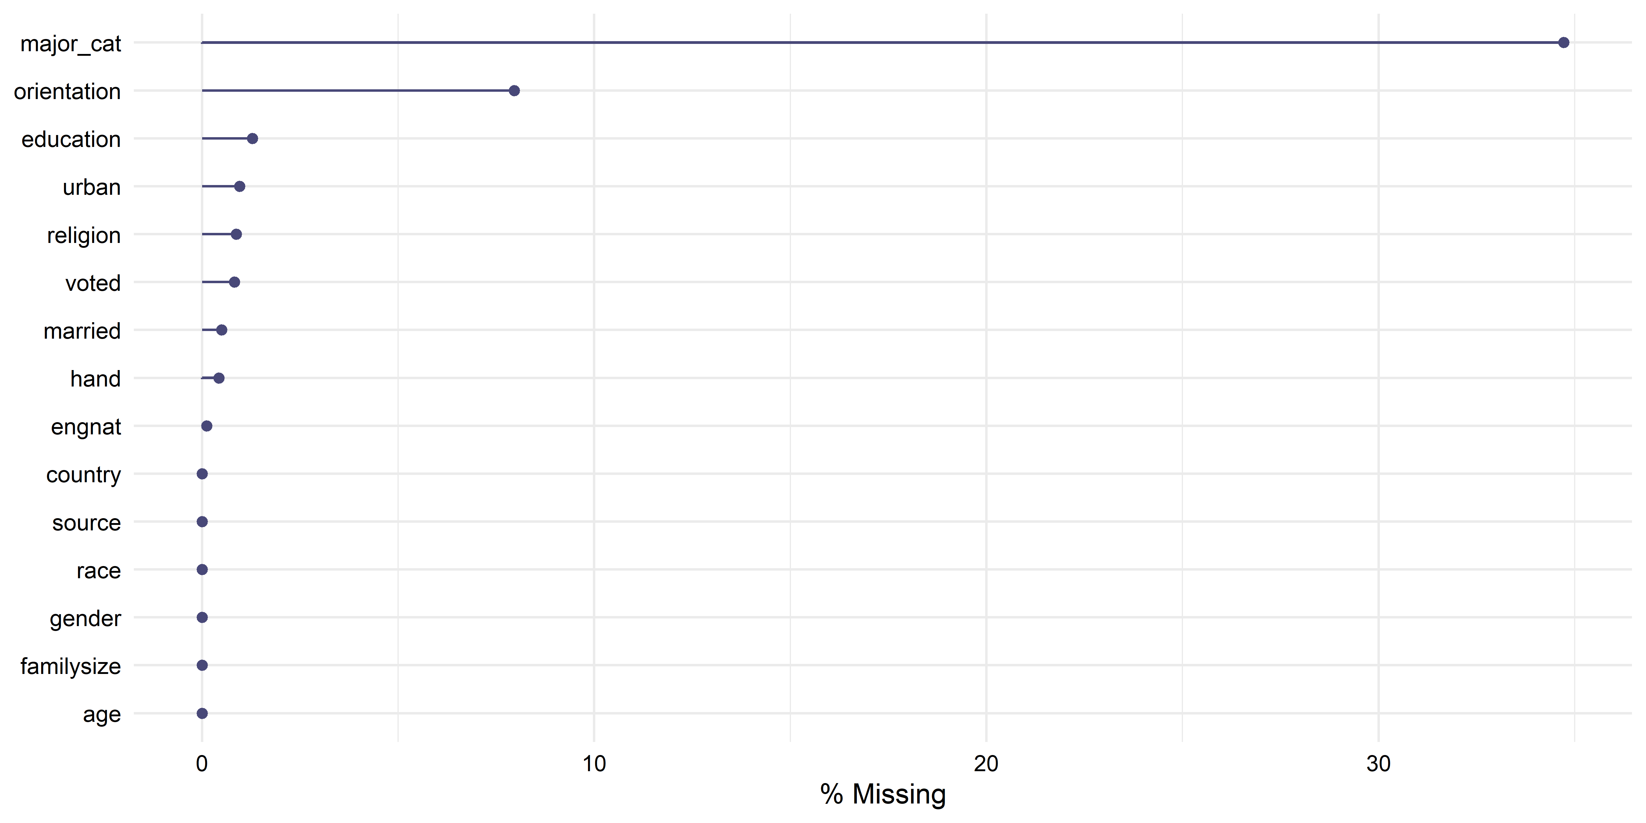
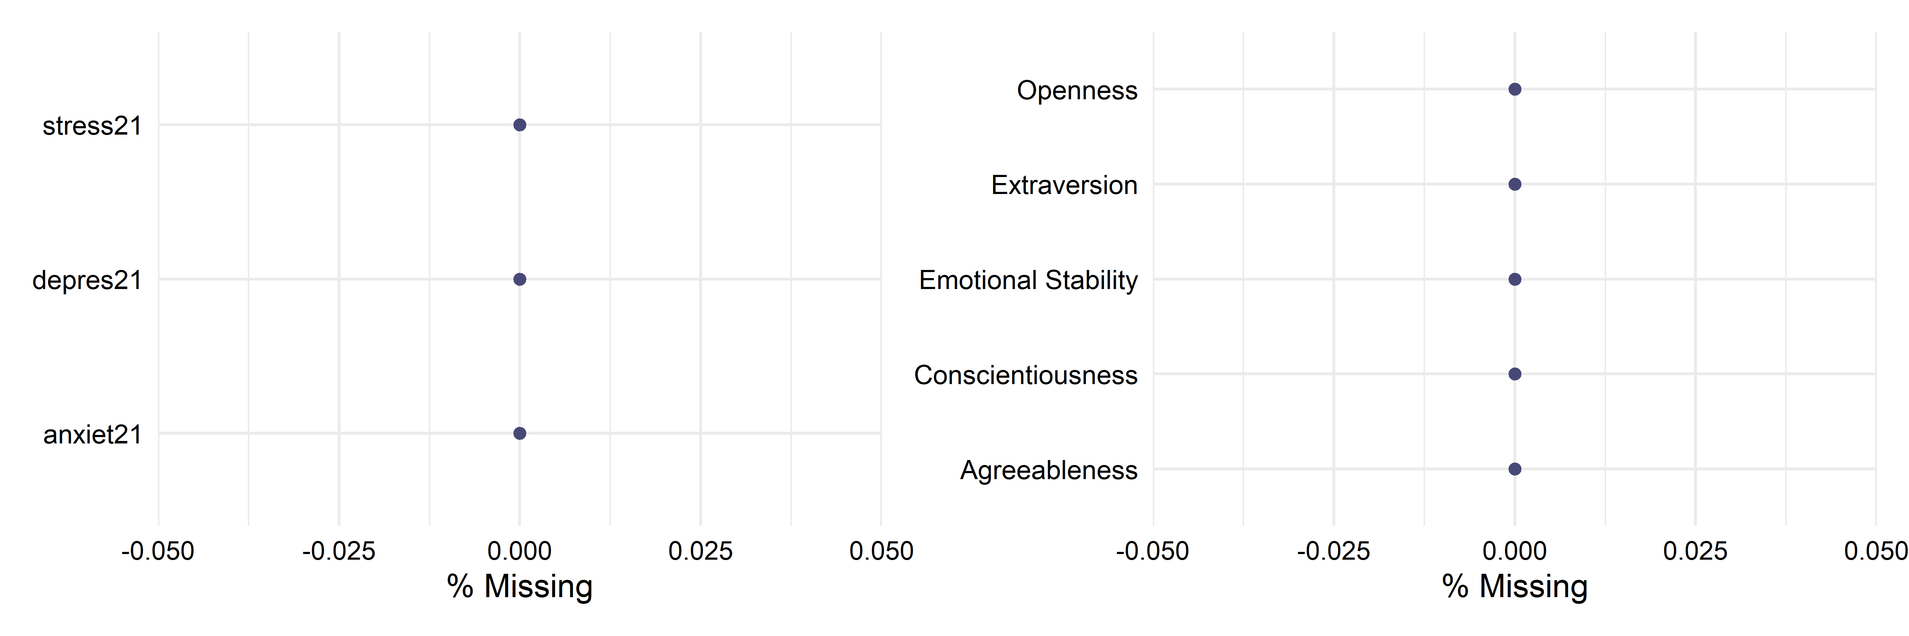

Fig. 2
Personality Difference Plots
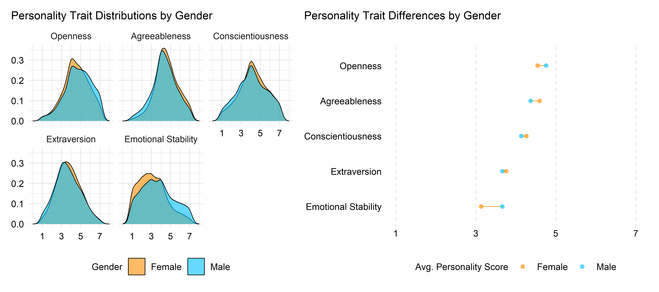
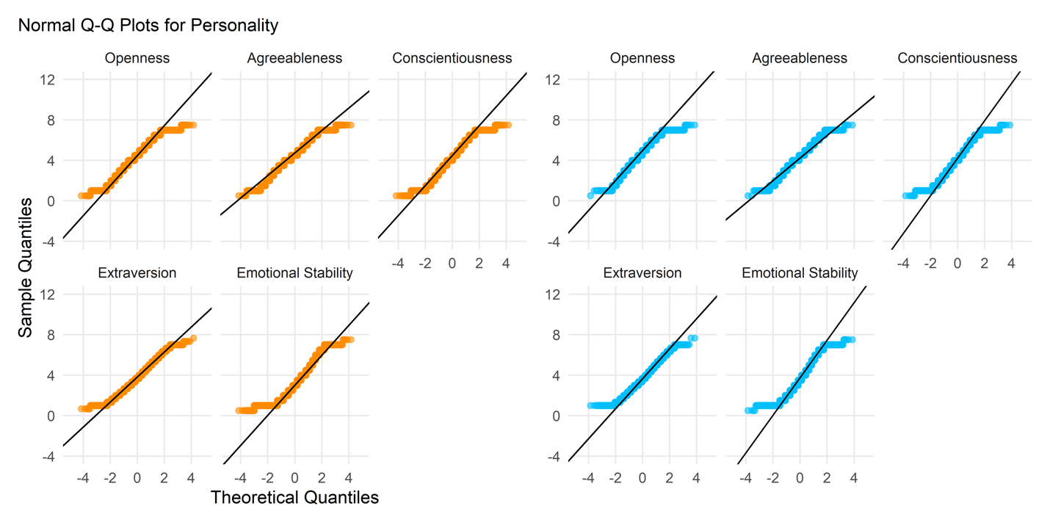

Fig. 3
Depression, Anxiety, Stress Difference Plots
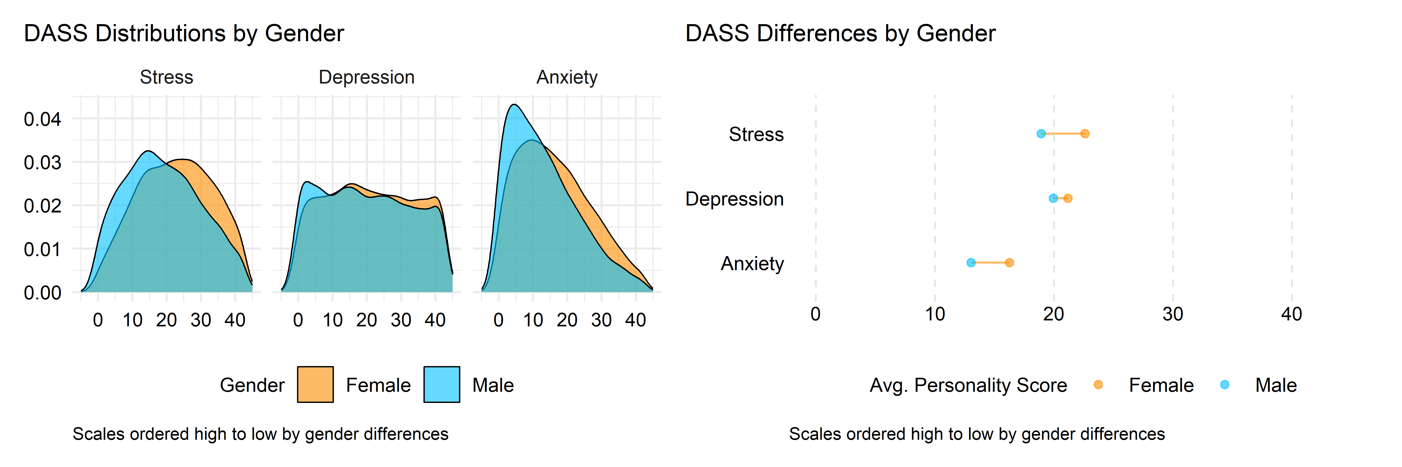
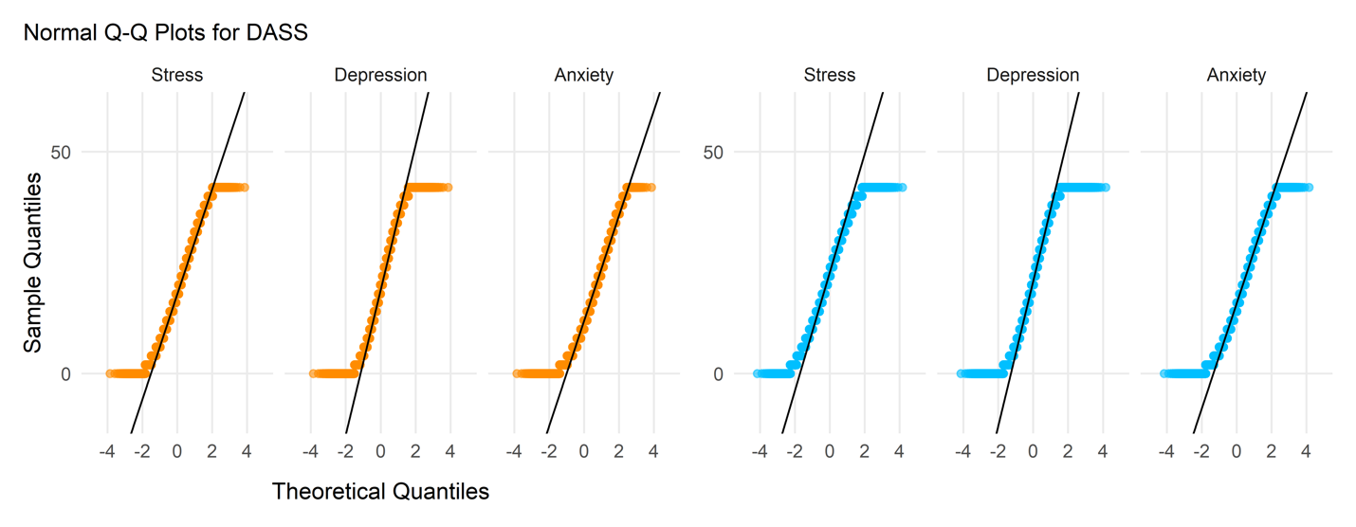

Fig. 4
Regression Coefficients for Personality Traits Predicting Depression, Anxiety, and Stress
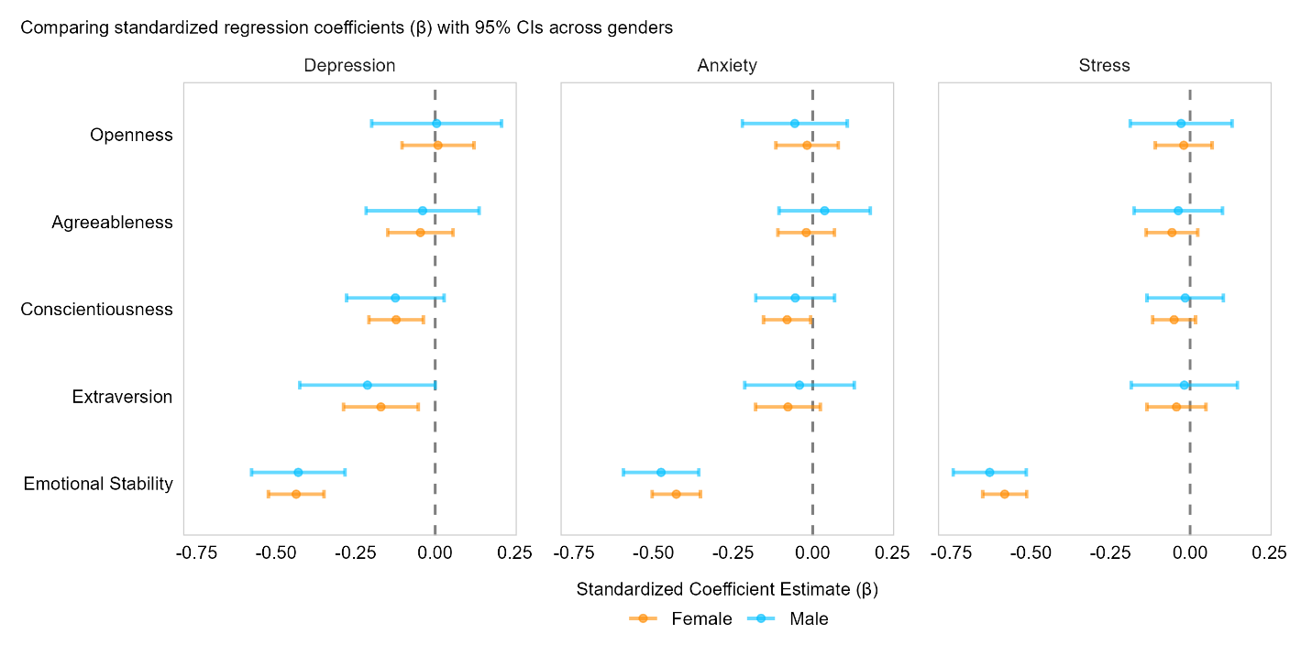
Note: Values reported are standardized regression coefficients, beta (β), with 95% confidence intervals. Coefficients are shown in descending order by female ranking.

Exploratory Data Analysis
Demographic EDA
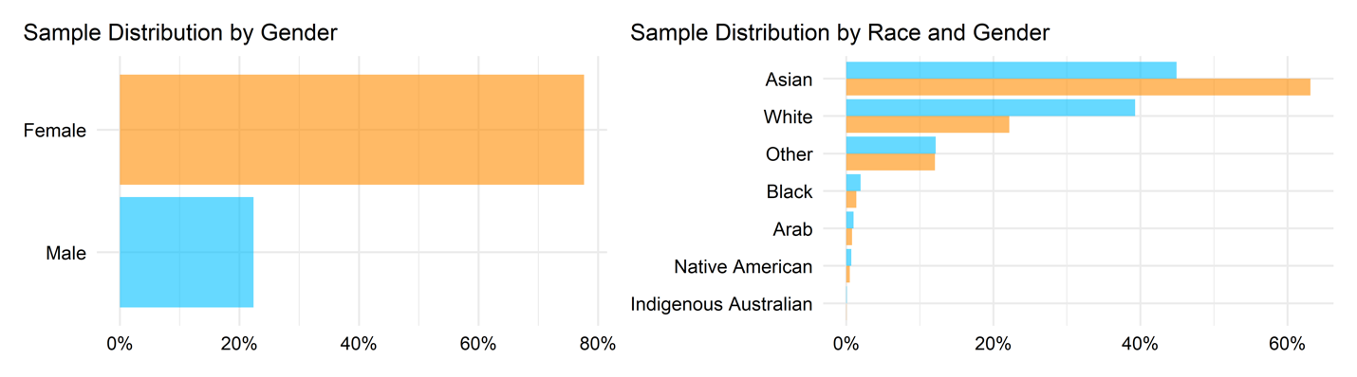
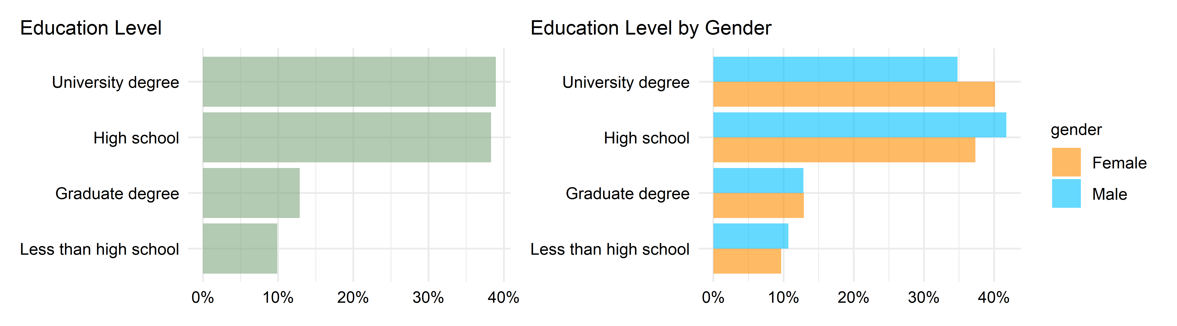
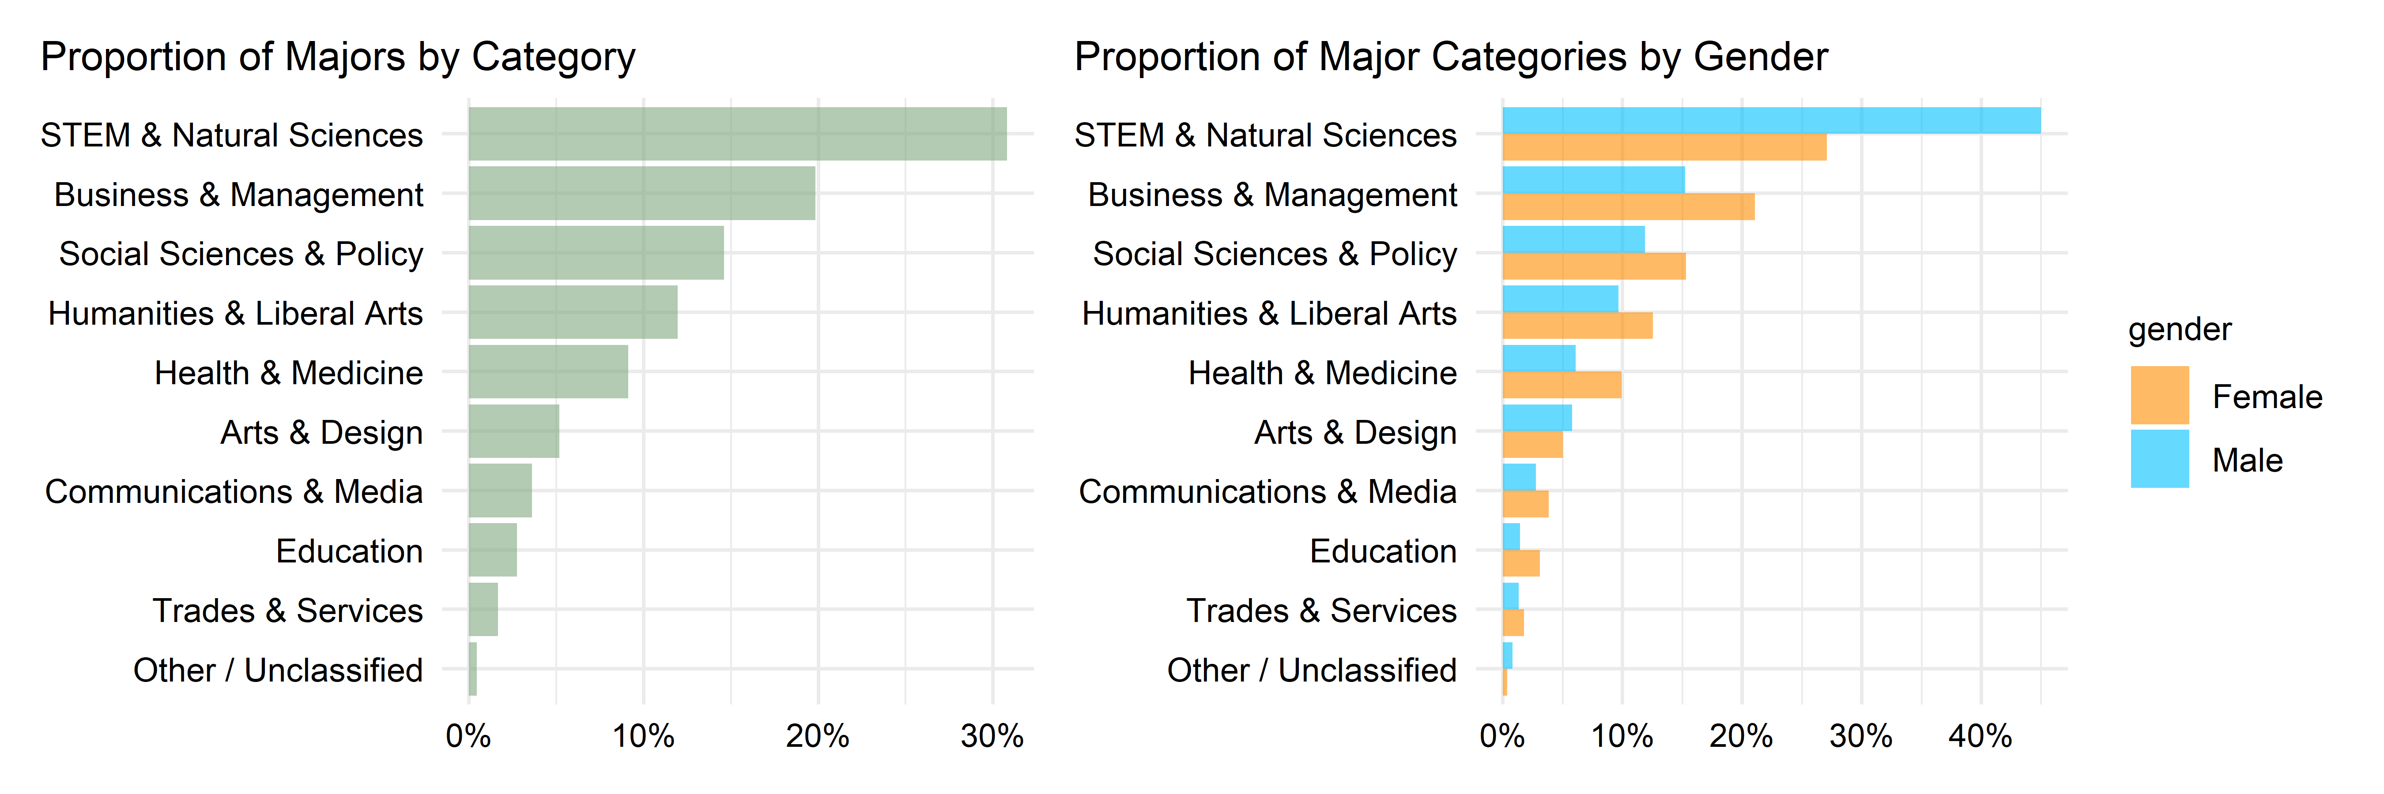
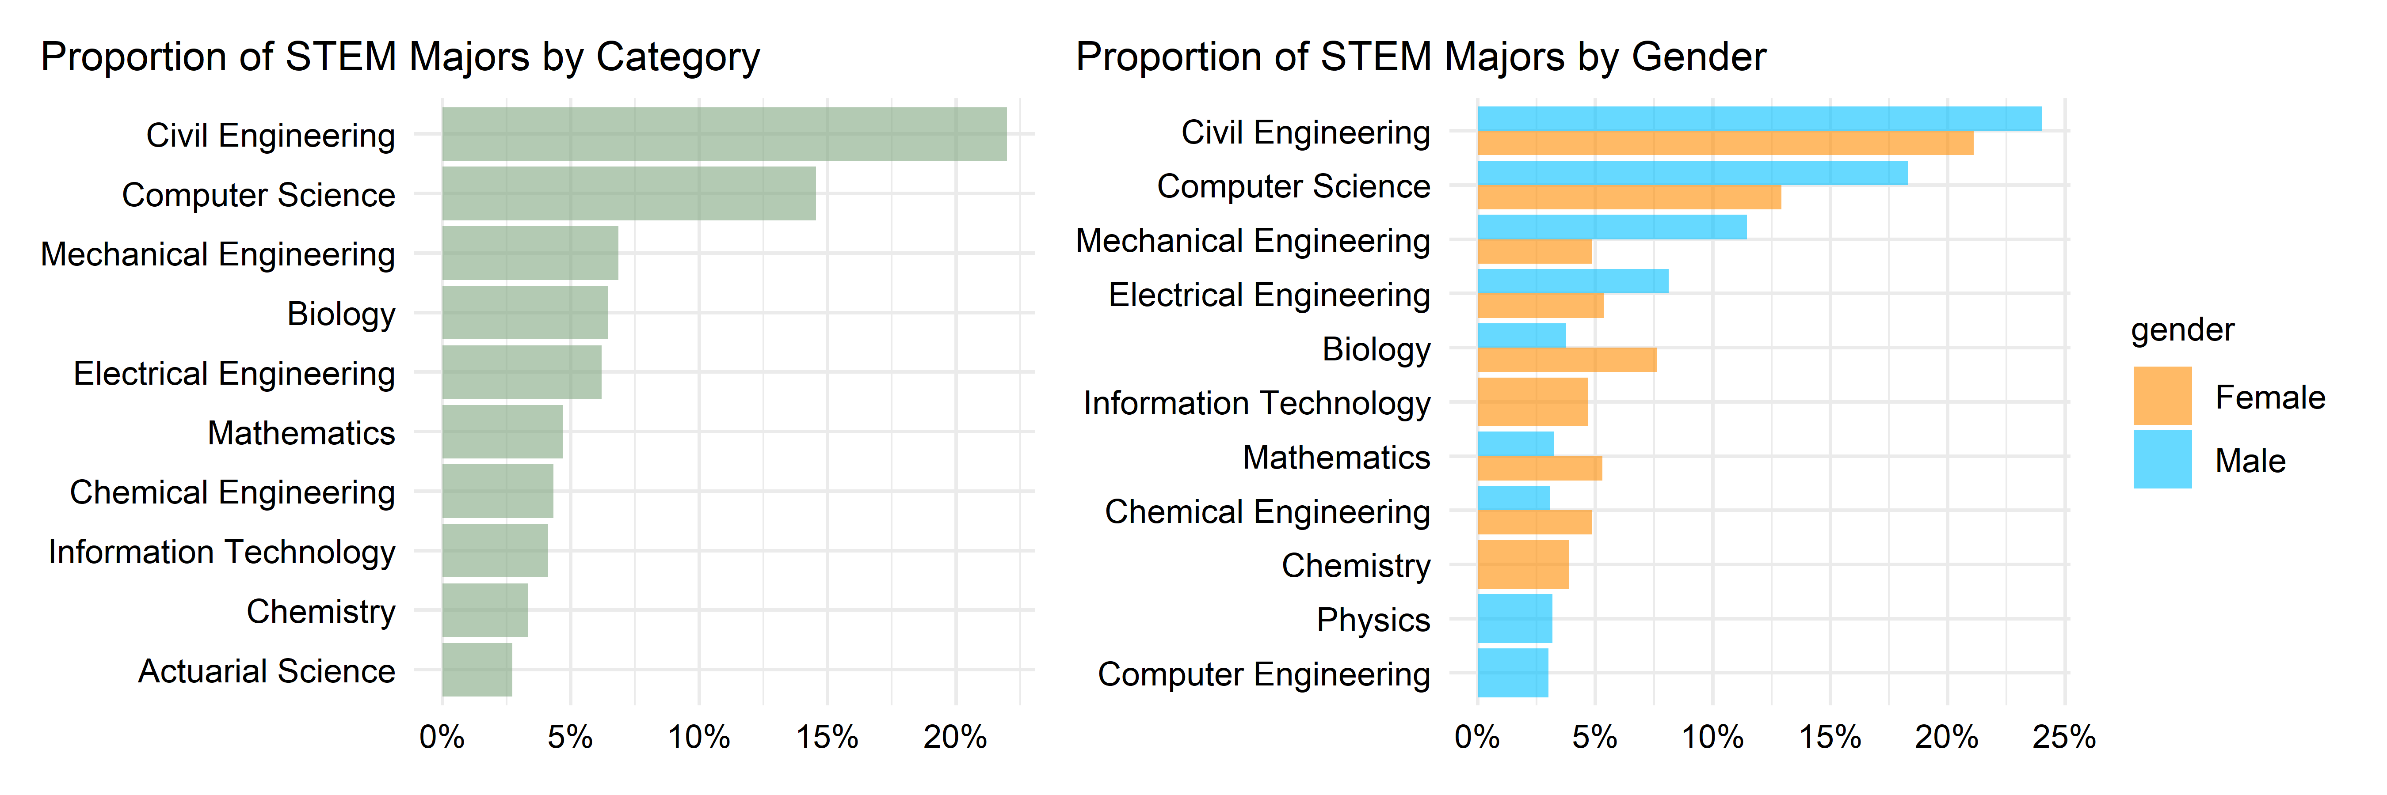
References
Alizadeh, Z., Feizi, A., Rejali, M., Afshar, H., Keshteli, A. H., & Adibi, P. (2018). The Predictive Value of Personality Traits for Psychological Problems (Stress, Anxiety and Depression): Results from a Large Population Based Study. Journal of Epidemiology and Global Health, 8(3), 124–133. https://doi.org/10.2991/j.jegh.2017.11.003
Amir, Y., & Sharon, I. (1990). Replication research: A “must” for the scientific advancement of psychology. Journal of Social Behavior and Personality, 5(4), 51–69.
Anvari, F., & Lakens, D. (2018). The replicability crisis and public trust in psychological science. Comprehensive Results in Social Psychology, 3(3), 266–286. https://doi.org/10.1080/23743603.2019.1684822
Behrendt, S. (2025). lm.beta: Add standardized regression coefficients to linear-model-objects (Version 1.7-3) [Computer software]. https://cran.r-project.org/web/packages/lm.beta/index.html
Ben-Shachar, M. S., Lüdecke, D., & Makowski, D. (2020). effectsize: Estimation of effect size indices and standardized parameters. Journal of Open Source Software, 5(56), 2815. https://doi.org/10.21105/joss.02815
Bentler, P. M., & Bonett, D. G. (1980). Significance tests and goodness of fit in the analysis of covariance structures. Psychological Bulletin, 88(3), 588–606. https://doi.org/10.1037/0033-2909.88.3.588
Bogdan, P. C. (2025). One decade into the replication crisis, how have psychological results changed? Advances in Methods and Practices in Psychological Science, 8(2), 25152459251323480. https://doi.org/10.1177/25152459251323480
Brown, R. M. (1983). Sudden Death. Bantam Books.
Brown, T. A. (2015). Confirmatory factor analysis for applied research (Second edition). The Guilford Press.
Chen, F. F. (2007). Sensitivity of goodness of fit indexes to lack of measurement invariance. Structural Equation Modeling: A Multidisciplinary Journal, 14(3), 464–504. https://doi.org/10.1080/10705510701301834
Cheung, G. W., & Rensvold, R. B. (2002). Evaluating Goodness-of-Fit Indexes for Testing Measurement Invariance. Structural Equation Modeling: A Multidisciplinary Journal, 9(2), 233–255. https://doi.org/10.1207/S15328007SEM0902_5
Finney, S., & DiStefano, C. (2006). Nonnormal and categorical data in structural equation modeling. In Hancock, G., Mueller, R. (Ed.), Structural equation modeling: A second course (pp. 269–314). Information Age.
Furr, M. (2018). Psychometrics: An introduction (3rd ed.). SAGE Publications Inc.
Goldberg, L. R. (1990). An alternative “description of personality”: The Big-Five factor structure. Journal of Personality and Social Psychology, 59(6), 1216–1229. https://doi.org/10.1037/0022-3514.59.6.1216
Gomez, R., Summers, M., Summers, A., Wolf, A., & Summers, J. (2014). Depression Anxiety Stress Scales-21: Measurement and structural invariance across ratings of men and women. Assessment, 21(4), 418–426. https://doi.org/10.1177/1073191113514106
Gosling, S. D., Rentfrow, P. J., & Swann, W. B. (2003). A very brief measure of the Big-Five personality domains. Journal of Research in Personality, 37(6), 504–528. https://doi.org/10.1016/S0092-6566(03)00046-1
Hayes, A. F., & Coutts, J. J. (2020). Use omega rather than Cronbach’s Alpha for estimating reliability. But…. Communication Methods and Measures, 14(1), 1–24. https://doi.org/10.1080/19312458.2020.1718629
Hirschfeld, G., & Brachel, R. von. (2014). Multiple-group confirmatory factor analysis in R – A tutorial in measurement invariance with continuous and ordinal indicators. Practical Assessment, Research, and Evaluation, 19(1). https://doi.org/10.7275/qazy-2946
Hu, L., & Bentler, P. M. (1999). Cutoff criteria for fit indexes in covariance structure analysis: Conventional criteria versus new alternatives. Structural Equation Modeling: A Multidisciplinary Journal, 6(1), 1–55. https://doi.org/10.1080/10705519909540118
Jaro, M. A. (1989). Advances in record-linkage methodology as applied to matching the 1985 census of Tampa, Florida. Journal of the American Statistical Association, 84(406), 414–420. https://doi.org/10.2307/2289924
Johnson, V. E., Payne, R. D., Wang, T., Asher, A., & Mandal, S. (2016). On the reproducibility of psychological science. Journal of the American Statistical Association, 112(517), 1. https://doi.org/10.1080/01621459.2016.1240079
Jorgensen, T. D., Pornprasertmanit, S., Schoemann, A. M., Rosseel, Y., Miller, P., Quick, C., Garnier-Villarreal, M., Selig, J., Boulton, A., Preacher, K., Coffman, D., Rhemtulla, M., Robitzsch, A., Enders, C., Arslan, R., Clinton, B., Panko, P., Merkle, E., Chesnut, S., … Vanbrabant, L. (2026). semTools: Useful Tools for Structural Equation Modeling (Version 0.5-8) [Computer software]. https://cran.r-project.org/web/packages/semTools/index.html
Ke, G., Meng, Q., Finley, T., Wang, T., Chen, W., Ma, W., Ye, Q., & Liu, T.-Y. (2017). LightGBM: A highly efficient gradient boosting decision tree. Proceedings of the 31st International Conference on Neural Information Processing Systems, NIPS’17, 3149–3157. https://dl.acm.org/doi/10.5555/3294996.3295074
Koole, S. L., & Lakens, D. (2012). Rewarding replications: A sure and simple way to improve psychological science. Perspectives on Psychological Science, 7(6), 608–614. https://doi.org/10.1177/1745691612462586
Korbmacher, M., Azevedo, F., Pennington, C. R., Hartmann, H., Pownall, M., Schmidt, K., Elsherif, M., Breznau, N., Robertson, O., Kalandadze, T., Yu, S., Baker, B. J., O’Mahony, A., Olsnes, J. Ø.-S., Shaw, J. J., Gjoneska, B., Yamada, Y., Röer, J. P., Murphy, J., … Evans, T. (2023). The replication crisis has led to positive structural, procedural, and community changes. Communications Psychology, 1, 3. https://doi.org/10.1038/s44271-023-00003-2
Lippa, R. A. (2010). Gender differences in personality and interests: When, where, and why?: Gender differences in personality and interests. Social and Personality Psychology Compass, 4(11), 1098–1110. https://doi.org/10.1111/j.1751-9004.2010.00320.x
Liu, Y., Millsap, R. E., West, S. G., Tein, J.-Y., Tanaka, R., & Grimm, K. J. (2017). Testing measurement invariance in longitudinal data with ordered-categorical measures. Psychological Methods, 22(3), 486–506. https://doi.org/10.1037/met0000075
Loo, M. P. J. van der. (2014). The stringdist Package for Approximate String Matching. The R Journal, 6(1), 111–122. https://doi.org/10.32614/RJ-2014-011
Lovibond, P. F., & Lovibond, S. H. (1995). The structure of negative emotional states: Comparison of the Depression Anxiety Stress Scales (DASS) with the Beck Depression and Anxiety Inventories. Behaviour Research and Therapy, 33(3), 335–343. https://doi.org/10.1016/0005-7967(94)00075-U
Lovibond, S. H., & Lovibond, P. F. (1995). Manual for the Depression Anxiety Stress Scales (2nd ed.). Psychology Foundation. https://www2.psy.unsw.edu.au/dass/
Lu, S., Hu, S., Guan, Y., Xiao, J., Cai, D., Gao, Z., Sang, Z., Wei, J., Zhang, X., & Margraf, J. (2018). Measurement invariance of the Depression Anxiety Stress Scales-21 across gender in a sample of Chinese university students. Frontiers in Psychology, 9, 2064. https://doi.org/10.3389/fpsyg.2018.02064
MacCallum, R. C., Browne, M. W., & Sugawara, H. M. (1996). Power analysis and determination of sample size for covariance structure modeling. Psychological Methods, 1(2), 130–149. https://doi.org/10.1037/1082-989X.1.2.130
Marsh, H. W., Hau, K.-T., & Wen, Z. (2004). In search of golden rules: Comment on hypothesis-testing approaches to setting cutoff values for fit indexes and dangers in overgeneralizing hu and bentler’s (1999) findings. Structural Equation Modeling: A Multidisciplinary Journal, 11(3), 320–341. https://doi.org/10.1207/s15328007sem1103_2
McCrae, R. R., & John, O. P. (1992). An Introduction to the Five-Factor Model and Its Applications. Journal of Personality, 60(2), 175–215. https://doi.org/10.1111/j.1467-6494.1992.tb00970.x
McDonald, R. P. (1999). Test theory: A unified treatment. Psychology Press. https://doi.org/10.4324/9781410601087
McNeish, D. (2018). Thanks coefficient alpha, we’ll take it from here. Psychological Methods, 23(3), 412–433. https://doi.org/10.1037/met0000144
Müller, K., Wickham, H., Francois, R., Bryan, J., Posit Software, & PBC. (2026). tibble: Simple Data Frames (Version 3.3.1) [Computer software]. https://cran.r-project.org/web/packages/tibble/index.html
Nevins, A., & Vaux, B. (2003). Metalinguistic, shmetalinguistic: The phonology of shmreduplication. 39. https://www.researchgate.net/publication/47760876_Metalinguistic_Shmetalinguistic_The_Phonology_of_Shmreduplication
Nosek, B. A., & Errington, T. M. (2020). What is replication? PLoS Biology, 18(3), e3000691. https://doi.org/10.1371/journal.pbio.3000691
Nosek, B. A., Hardwicke, T. E., Moshontz, H., Allard, A., Corker, K. S., Dreber, A., Fidler, F., Hilgard, J., Struhl, M. K., Nuijten, M. B., Rohrer, J. M., Romero, F., Scheel, A. M., Scherer, L. D., Schönbrodt, F. D., & Vazire, S. (2022). Replicability, robustness, and reproducibility in psychological science. Annual Review of Psychology, 73(Volume 73, 2022), 719–748. https://doi.org/10.1146/annurev-psych-020821-114157
Nunnally, J. C. (1994). The assessment of reliability. In Psychometric Theory (3rd ed., pp. 248–292). McGraw-Hill.
Open Psychometrics. (2019). Answers to the depression anxiety stress scales [Dataset]. https://openpsychometrics.org/_rawdata/
Open-Source Psychometrics Project. (2019, September 17). About the Open-Source Psychometrics Project. https://openpsychometrics.org/about/
Patil, P., Peng, R. D., & Leek, J. T. (2016). What should we expect when we replicate? A statistical view of replicability in psychological science. Perspectives on Psychological Science : A Journal of the Association for Psychological Science, 11(4), 539. https://doi.org/10.1177/1745691616646366
Pedersen, T. L. (2025). patchwork: The composer of plots (Version 1.3.2) [Computer software]. https://cran.r-project.org/web/packages/patchwork/index.html
Pittelkow, M.-M., Field, S. M., Isager, P. M., van’t Veer, A. E., Anderson, T., Cole, S. N., Dominik, T., Giner-Sorolla, R., Gok, S., Heyman, T., Jekel, M., Luke, T. J., Mitchell, D. B., Peels, R., Pendrous, R., Sarrazin, S., Schauer, J. M., Specker, E., Tran, U. S., … van Ravenzwaaij, D. (2023). The process of replication target selection in psychology: What to consider? Royal Society Open Science, 10(2), 210586. https://doi.org/10.1098/rsos.210586
Posit Team. (2026). RStudio: Integrated development environment for R (Version 2026.01.0+392 “Apple Blossom” Release) [R; Windows]. Posit Software, PBC. http://www.posit.co/
R Core Team. (2026). R: A Language and Environment for Statistical Computing (Version 4.6.0) [Computer software]. R Foundation for Statistical Computing. https://www.R-project.org/
Robinson, D., Hayes, A., Couch, S., Hvitfeldt, E., Posit Software, PBC, Patil, I., Chiu, D., Gomez, M., Demeshev, B., Menne, D., Nutter, B., Johnston, L., Bolker, B., Briatte, F., Arnold, J., Gabry, J., Selzer, L., Simpson, G., … Reinhart, A. (2026). broom: Convert Statistical Objects into Tidy Tibbles (Version 1.0.13) [Computer software]. https://cran.r-project.org/web/packages/broom/index.html
Rosseel, Y. (2012). lavaan: An R Package for Structural Equation Modeling. Journal of Statistical Software, 48(2). https://doi.org/10.18637/jss.v048.i02
Sambol, S., Suleyman, E., Scarfo, J., & Ball, M. (2022). Distinguishing between trait emotional intelligence and the five-factor model of personality: Additive predictive validity of emotional intelligence for negative emotional states. Heliyon, 8(2), e08882. https://doi.org/10.1016/j.heliyon.2022.e08882
Satterthwaite, F. E. (1946). An approximate distribution of estimates of variance components. Biometrics Bulletin, 2(6), 110. https://doi.org/10.2307/3002019
Shrout, P. E., & Rodgers, J. L. (2018). Psychology, science, and knowledge construction: Broadening perspectives from the replication crisis. Annual Review of Psychology, 69(Volume 69, 2018), 487–510. https://doi.org/10.1146/annurev-psych-122216-011845
Svetina, D., Rutkowski, L., & Rutkowski, D. (2020). Multiple-group invariance with categorical outcomes using updated guidelines: An illustration using M plus and the lavaan/semTools packages. Structural Equation Modeling: A Multidisciplinary Journal, 27(1), 111–130. https://doi.org/10.1080/10705511.2019.1602776
Tierney, N., & Cook, D. (2023). Expanding tidy data principles to facilitate missing data exploration, visualization and assessment of imputations. Journal of Statistical Software, 105, 1–31. https://doi.org/10.18637/jss.v105.i07
Uliaszek, A. A., Zinbarg, R. E., Mineka, S., Craske, M. G., Sutton, J. M., Griffith, J. W., Rose, R., Waters, A., & Hammen, C. (2010). The role of neuroticism and extraversion in the stress–anxiety and stress–depression relationships. Anxiety, Stress, & Coping, 23(4), 363–381. https://doi.org/10.1080/10615800903377264
Vujicic, M., & Randjelovic, D. (2017). Personality traits as predictors of depression, anxiety, and stress with secondary school students of final years. Зборник Радова Филозофског Факултета у Приштини, (47–3), 217–237. https://doi.org/10.5937/ZRFFP47-14984
Weisberg, Y. J., DeYoung, C. G., & Hirsh, J. B. (2011). Gender differences in personality across the ten aspects of the Big Five. Frontiers in Psychology, 2. https://doi.org/10.3389/fpsyg.2011.00178
Welch, B. L. (1947). The generalization of `Student’s’ problem when several different population variances are involved. Biometrika, 34(1/2), 28–35. https://doi.org/10.2307/2332510
Wickham, H., Averick, M., Bryan, J., Chang, W., McGowan, L. D., François, R., Grolemund, G., Hayes, A., Henry, L., Hester, J., Kuhn, M., Pedersen, T. L., Miller, E., Bache, S. M., Müller, K., Ooms, J., Robinson, D., Seidel, D. P., Spinu, V., … Yutani, H. (2019). Welcome to the Tidyverse. Journal of Open Source Software, 4(43), 1686. https://doi.org/10.21105/joss.01686
Wickham, H., Henry, L., Posit Software, & PBC. (2026). purrr: Functional programming tools (Version 1.2.2) [Computer software]. https://cran.r-project.org/web/packages/purrr/index.html
Wickham, H., Pedersen, T. L., Seidel, D., Posit Software, & PBC. (2025). scales: Scale functions for visualization (Version 1.4.0) [Computer software]. https://cran.r-project.org/web/packages/scales/index.html
Winkler, W. E. (1990). String comparator metrics and enhanced decision rules in the fellegi-sunter model of record linkage. https://eric.ed.gov/?id=ED325505
Wu, H., & Estabrook, R. (2016). Identification of Confirmatory Factor Analysis Models of Different Levels of Invariance for Ordered Categorical Outcomes. Psychometrika, 81(4), 1014–1045. https://doi.org/10.1007/s11336-016-9506-0
Xie, Y. (2025). knitr: A General-Purpose Package for Dynamic Report Generation in R (Version R package 1.51) [Computer software]. https://yihui.org/knitr/
Youyou, W., Yang, Y., & Uzzi, B. (2023). A discipline-wide investigation of the replicability of Psychology papers over the past two decades. Proceedings of the National Academy of Sciences, 120(6), e2208863120. https://doi.org/10.1073/pnas.2208863120
Zhu, H., Travison, T., Tsai, T., Beasley, W., Xie, Y., Yu, G., Laurent, S., Shepherd, R., Sidi, Y., Salzer, B., Gui, G., Fan, Y., Murdoch, D., Arel-Bundock, V., & Evans, B. (2024). kableExtra: Construct Complex Table with “kable” and Pipe Syntax (Version 1.4.0) [Computer software]. https://doi.org/10.32614/CRAN.package.kableExtra

